**PAYROLL MANAGEMENT SYSTEM**

Megh Poddar Rishabh Singh Umer Qureshi

SE-IT-B-10 SE-IT-B-71 SE-IT-B-73

meghpoddar@gmail.com rishabhsingh054@gmail.com dqureshiumar@gmail.com

**Executive Summary :**

Payroll Management System (PMS) is a system which is used to maintain records of all the users working in an organization, providing an easy GUI to the Admin. This System is per organization. At the front end of the system we have used Spring Tool Suite IDE in JAVA technology and Spring Inbuilt server for maintaining databases. The project proceeds through a sequence of well designed JSP pages with validation to security, consistency, reliability, etc. Various users are provided which can perform various operations and tasks for which they have been authorized respectively. Basically there are 2 types of users: Employee and Admin. Admin is fully authorized. While other users are authorized upto a certain level. Based on the user authorisation, users can perform various operations like Adding information of new Employee, Updating information, View list of employees, generate pay slip of particular employee, Generate report of the organization. This system is very user friendly and easily maintains all the information for all kind off users without any difficulties. The system also generates fault and error messages in case of invalid operation or the user enters invalid or wrong information for some particular cases.

**Problem Statement :**

Purpose of making this web application is to create a portal for Start-ups and Various companies to provide their employee a payroll that shows the employee their monthly income including incentives, bonuses and taxes respectively. Generating a payroll helps the company keep record of the salary given to all the employee in their organisation. Having access to this information can improve employee satisfaction, while also saving human resources professionals' time.

**Description**

Payroll Management System is the system that maintains all the records of all employees of an organisation. This system is developed to ease the process of searching and maintaining the valuable records of all type of users (i.e employees). Payroll Management System that is easy to understand, easy to use and offers the simplicity of managing various records of an organisaton. This powerful software program is specifically designed for maintaining overall information of an organisation. This intuitive visual interface makes various aspects of performing various operations related with all the kind of users. PMS controls all back-end functionalities like generating pay slips.

**Findings**

The prime focus for many Start Ups, at the very initial stage is “Revenue Growth and reduction in Unnecessary Cost. A tight control on these two important areas would take them a long way in this swiftly business world.

Many companies Track attendance ,Working hours, Overtime, Assigned Task and Projects, Task Deadlines, Salary calculation, PF, ESIC, LWF, PT all these calculations manually, which is obviously prone to human errors and a "Little defense against Legal issue".

In the era of automation where most of the business process are digitized technology can have a significant impact at key stages of the employee life cycle.

At HRGird we identify that improving these basic HR process, will take an organization to the next level and would inculcate a positive experience for potential as well as existing employees, improving employee engagement in the long run. Understanding and accepting that every organization need is different, we provide customize solutions (Online + On Premises) as per the organizations need.

**Implementation**

Basic implementation of employee payroll management system has been done in which the admin maintains all the records of all employees of an organisation.

Admin will first register all the employee under the organisation . Admin has the privilege to update and manage the users data stored under the database. Admin is a user who manages information about all the employees as well as generating pay slips. The Admin will enter the Employee Details to generate the payslip and can send it via mail to the employee’s email. The Admin can also print the Payroll of the employee and send it to the employee respectively.

**Discussion:**

1. Enter Details of All Employee.
2. Select the Employee for whom you want generate Payroll.
3. When Payroll is generated select either to print or send it via email ( you can do both).
4. Logout.

**Input Study :**

1. Validation is done at the user end.
2. Session handling is properly done in the database.

**Result:**

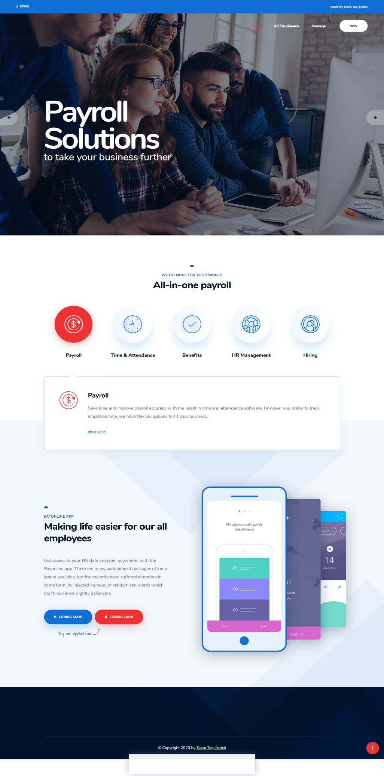

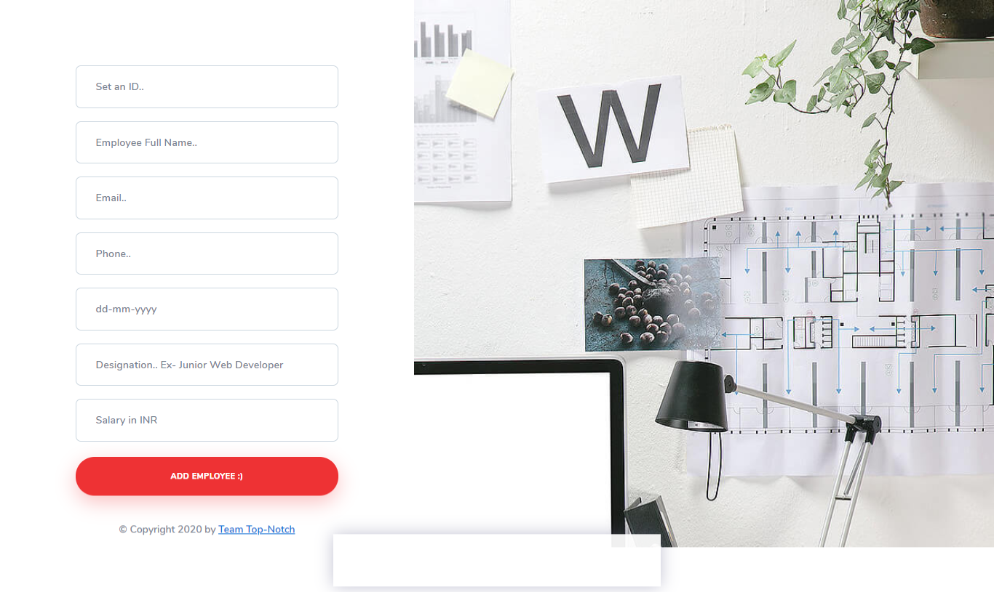

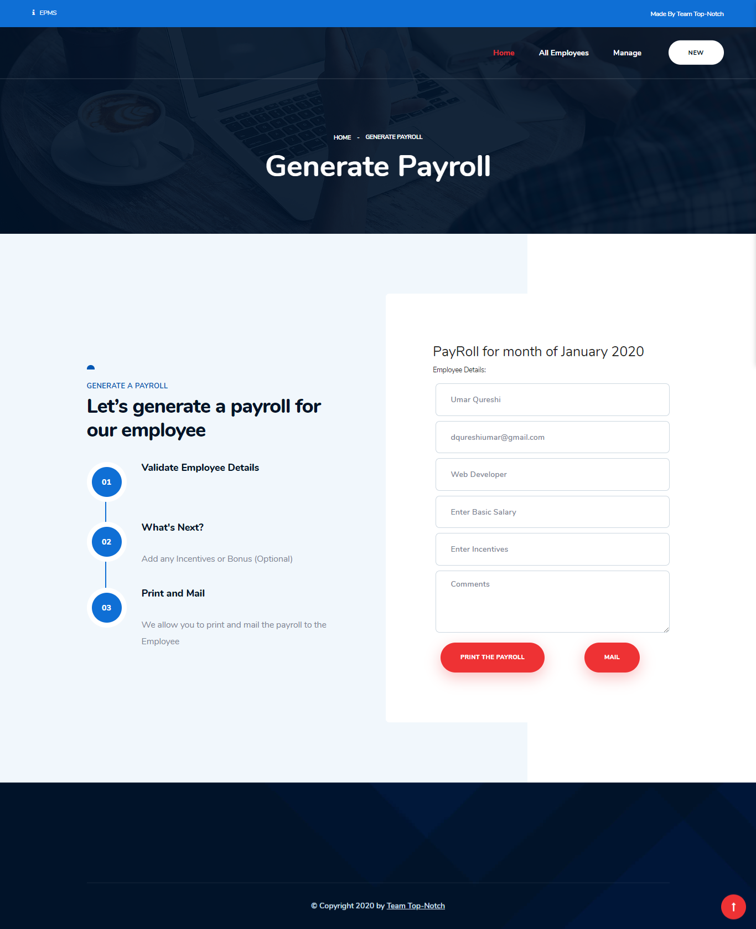

**Conclusion:**

We have implemented a project by understanding all the modules of this project. We have checked the feasibility and the requirements of the system. Then we designed the GUI and the flow control roughly on the paper. After this the actual implementation our modules was started. Initially all the modules were developed separately and lately all were integrated with each other. Next phase we came across was testing. We tested each module individually and later the whole system. And thus through this system, an organization can easily maintain records of all the users efficiently and can perform various operations easily.

We experienced an enhancement in our Designing and technical skills of programming through the development of this Software.